ATTENTION FIRST-YEAR STUDENTS of academic year 2017/2018
(first degree, second degree and uniform master's and doctoral studies)
Training on health and safety and fire protection available only as an e-learning course

Ladies and Gentlemen,
It is the responsibility of each student commencing studies at the University of Wroclaw to participate in training on health and safety and fire protection. The course is mandatory and ends with a test. Training is considered to be completed on the basis of minutes of the training.

The training in the field of occupational health and safety and fire protection lasts from 16 October 2017 to 30 January 2018.

Open a page https://e-edu.cko.uni.wroc.pl/

How to start your training?
- Login using menu in an upper right corner
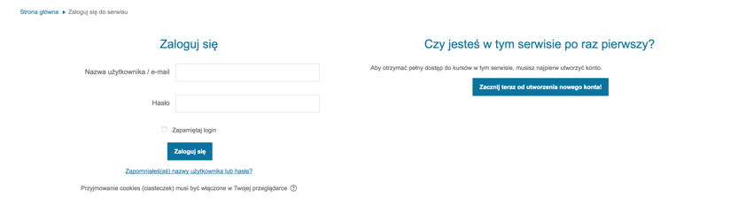
2. If this is your first login:
a. Complete the user profile (name, surname, faculty and field of study) and save changes with the button at the end of the form.
b. The following information will appear: 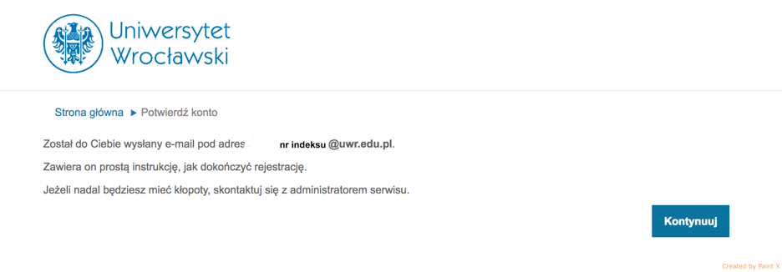
3. After completing the registration made according to the posted instruction, log on to the portal https://e-edu.cko.uni.wroc.pl/
4. Locate the course: Initial training in the field of health and safety and fire protection.
5. Sign up for a course using access key: BHP-18
6. Familiarize yourself with the modules of the course and complete the test. Materials should be viewed consecutively starting from the module “Introduction to training”. Pay attention to the symbols of completing the modules (on the right).
7. Check your grade after completing the test.
Any information on the above matter shall be given by the Department of Health and Safety and Fire Protection - tel.: (71) 375-24-89. IT Support Karol Greinert tel. 509 275 001 in 7am to 8pm Monday to Friday.

